2023 Youth and Young Adult Art Contest:
Together on the Journey of Hope

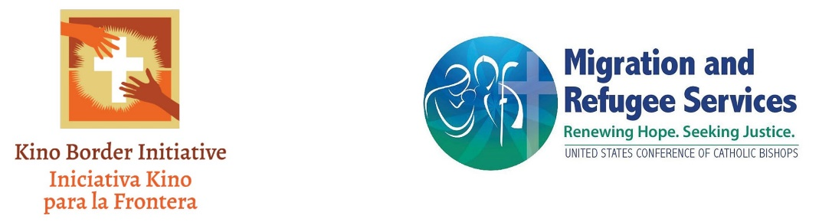

2023 Youth and Young Adult Art Contest:
Together on the Journey of Hope

Rules

- 2023 Youth and Young Adult Art Contest: Together on the Journey of Hope
  - The USCCB Office of Migration and Refugee Services is hosting a youth and young adult art contest that highlights the subtitle of the letter, which reads “Together on the Journey of Hope.”
  - The Together on the Journey of Hope Contest (hereinafter, the “Contest”) requires participants to represent the ways people in migration walk together on the journey, with their families, with others they meet along the way, with communities in the US who receive and accompany them, with advocates who seek more dignified migration alongside them. Entries could also paint a picture of the artist’s vision for what they hope the migration journey could look like in the future: what does it look like to, as the pastoral letter states, “help newcomers integrate in ways that are respectful, that celebrate their cultures, and that are responsive to their social needs, leading to a mutual enrichment of the local church?” What images, words or colors represent this “journey of hope?”
  - By submitting an entry to the Contest, the entrant agrees to abide by all Contest rules.
    - An entry is defined as a piece of art in one of three categories: 1. painting or drawing, 2. Photography, or 3. Poetry. submitted to the Contest for evaluation by the judges.
    - Only one entry in total is allowed per participant, regardless of under which rubric the piece of art falls under.
- Eligibility criteria. Failure to abide by the following rules may make the applicant subject to disqualification.
  - Immediate family or household members of any employee of the United States Conference of Catholic Bishops (hereinafter, “USCCB” or “the Conference”), Our Sunday Visitor (hereinafter, “OSV”), or any Judge of the Contest are ineligible to enter the Contest and are hereby disqualified.
  - Contest is open to all youth, ages 5- 18. Participation will be based on four age categories: 5 – 9, 10 – 13, 14 – 18, and 19-22.
  - No entry fee is required. Upon submission, each entrant is agreeing, acknowledging and providing USCCB with all right, title and interest, including but not limited to the copyright, of the submitted essay all derivative works thereof and sole and exclusive ownership thereto. USCCB is permitted to use and publish the essay in its sole and exclusive discretion. Entrants represent and warrant the submitted essay does not conflict, infringe or violate any third-party rights and agree to indemnify, hold harmless and defend the Conference from any and all liability that may arise in connection with participation in the Contest. Entrants agree that any submission has not been, and will not be, submitted to any other person or entity for publication.
  - Submissions must include an original work of art by the youth/young adult.
  - Posters may include multiple mediums such as crayons, markers, paint, pastels, etc.
  - Use of any inappropriate image or language will automatically disqualify the entry.

- Submissions. Submissions should be sent via email to artcontest@usccb.org.
- Originality. All entries must be original works by the entrant. Plagiarism, which includes the use of third-party pictures, artwork, ideas, representations, or any sort of intellectual property without the proper attribution or citation, or infringement of third-party rights of any kind without limitation will result in disqualification. Entries may not have been previously published or submitted for publication in any sort of media.
- We accept only entries that do not require a delivery signature for us to receive them.
- Prizes. There shall be one $40.00 Visa Gift Card prize in each age group and category. The age group and categories are as follows.
  - Age category 5 – 9 painting or drawing
  - Age category 5 – 9 Photography
  - Age category 5 – 9 Poetry
  - Age categories 10 – 13 painting or drawing
  - Age categories 10 – 13 Photography
  - Age categories 10 – 13 Poetry
  - Age categories 14 – 18 painting or drawing
  - Age categories 14 – 18 Photography
  - Age categories 14 – 18 Poetry
  - Age categories 19 – 22 painting or drawing
  - Age categories 19 – 22 Photography
  - Age categories 19 – 22 Poetry
- Deadline. Essays must be submitted on or before 11:59 p.m. eastern standard time on May 19, 2023 (the “Deadline”). Submissions received after the Deadline are automatically disqualified from the Competition.
- Number of Entries. Each entrant may submit only one piece of art regardless of category.
- Revisions of Submissions. No revisions to the artwork will be allowed once it has been submitted.
- Judging. Entries will be judged by a panel of judges chosen by the USCCB. The choice of judges is wholly within the discretion of the USCCB. The decisions of the judges are their own, and are final and binding. No appeal may be taken from a judge’s decision and any such attempted appeal is grounds for automatic disqualification from the Contest.
- Grading. Entries will be judged based on their originality and how well they encapsulate the prompt provided. In the event of a tie, the entry that is most effective in encapsulating the prompt provided will be chosen as the winner.
- Winner Announcement. Winners will be announced on June 20, 2023.
- Winners. Winners will be individually notified of the results by phone, mail, or e-mail.
- Tax Consequences. Cash prizes may have tax consequences for the selected contestant. The Conference will not withhold any tax from the price earnings. Contestants should speak with a tax advisor about how the earnings may impact their taxes.
- Amendment to Rules. The Conference reserves the right to amend, change or modify the rules of the Contest in its sole discretion. Any changes or modification will be effective immediately upon posting of the revisions on the Contest site, and you waive any right you may have to receive specific notice of such changes or modifications.
- Void. This Contest is void where prohibited by law.

Permission to participate and Parental Consent Form

We request that you complete this form to confirm that you are authorizing your entry into the Competition on behalf of yourself or your minor child. The Rules can be found above and at https://www.usccb.org/committees/migration/MRSart. Please read the information contained in the Official rules and this Consent Form carefully before you complete it. Please complete and return this form along with the Contest entry.

I, the undersigned, certify that I am either the Contestant; or the parent or legal guardian of the below-mentioned Contestant.

I hereby authorize the entry of the Contestant named below to participate in the Contest.

Full name Contestant: ___________________________________________________________
Name of artwork (“Artwork”): ____________________________________________________
Age: _________________________________________________________________________
Parent’s/Guardian’s full name: ____________________________________________________
Contact email address: __________________________________________________________
Contact phone number: __________________________________________________________

I confirm that by completing this form, I have read, understood and agreed to the rules for the Contest and that the Contestant will abide by the Art Contest Guidelines. I confirm that the information given in this consent form is complete and accurate. I agree and understand that USCCB shall be the sole and exclusive owner of the Artwork and rights, title and interest in and to the Artwork and any derivative works thereof, including but not limited to the copyright, and that USCCB shall own or be licensed to use any materials and/or elements embodied in the Artwork which are not original to Contestant, and which Contestant shall secure rights, permissions or licenses thereof and provide documentation to USCCB upon request. I agree on behalf of myself, the contestant, my heirs, assigns, executors, and personal representatives, to indemnify USCCB, its member bishops, employees, officers, affiliates, representatives, assigns and successors hold harmless and defend the USCCB from any and all liability that may arise in connection from my own/my child’s participation in the USCCB 2023 Youth and Young Adult Art Contest: Together on the Journey of Hope. I agree that that USCCB may use, assign, license or otherwise transfer its rights under this Agreement and that this Agreement shall inure to the benefit of USCCB’s assigns, successors and licensees.

Contestant grants USCCB the exclusive right to use the photography depicting the Contestant for inclusion in written, audio-visual, and digital materials now known or later developed in perpetuity on the subject of and any ancillary use or derivate works and for all promotional, marketing and merchandising purposes. Contestant acknowledges that the depiction of him/her in the Photo may be duplicated and distributed in any and all manner and in any media now known or later developed throughout the world in perpetuity.

Contestant and USCCB have indicated their acceptance of this Agreement by signing below:

______________________________________________________ _________________
Signature of Contestant (if over 18) or Parent or Legal Guardian Date

